Step by step to use Stack Maker Level Editor:

1. Open Project and open Tile Palette window by clicking Window / 2D / Tile Palette.

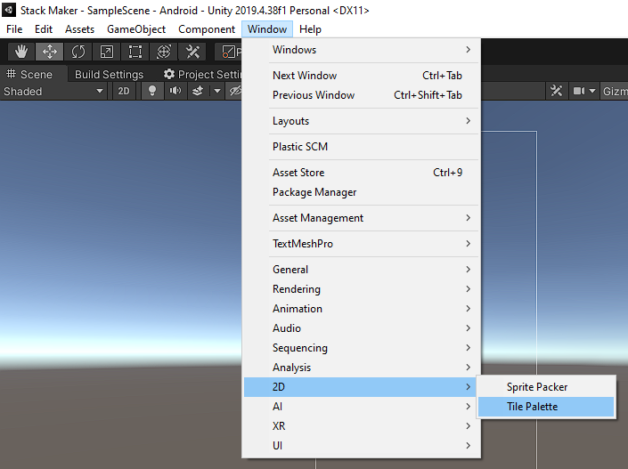

1. Choose the Level Controller object in the Hierarchy and its Inspector will appear.

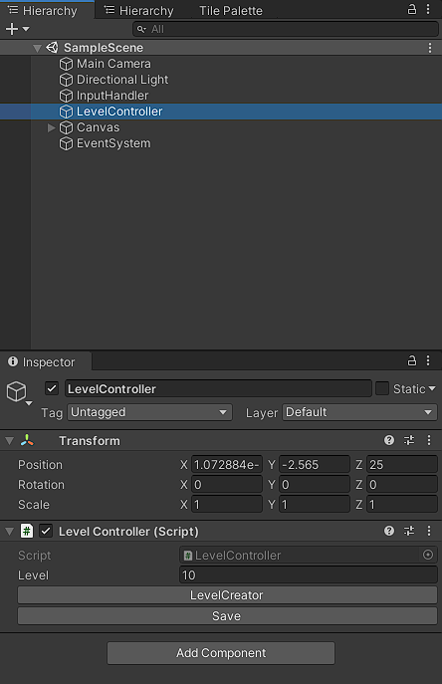

1. Click Level Creator button to start drawing a new level => a Level Template(Clone) (which include Player object, Win object and Grid to draw map) will be created

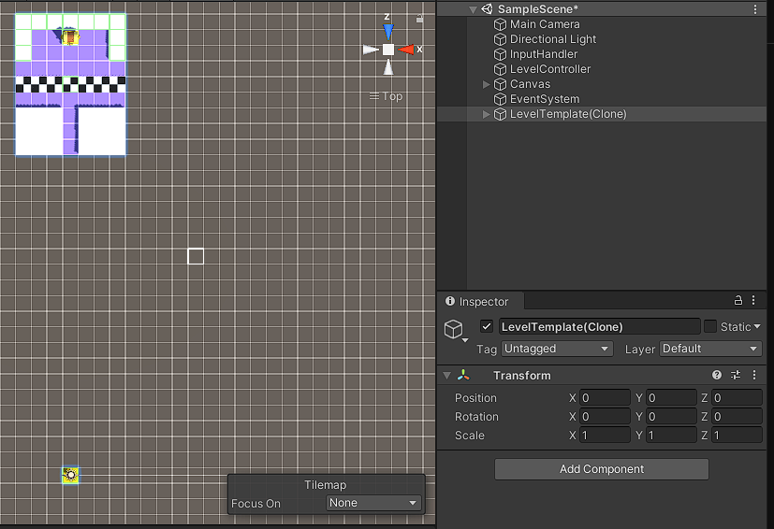

1. Choose the Tile Palette window and change Active Tilemap to “Map”.

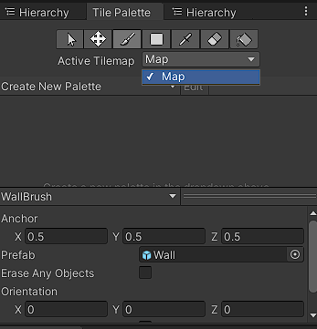

1. Choose EdibleBrush to draw Edible Block

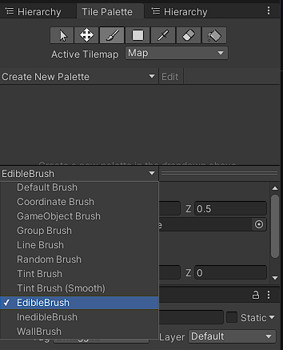 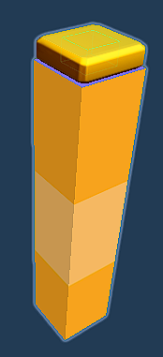

or InedibleBrush for Inedible Block

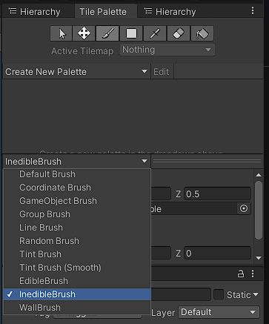 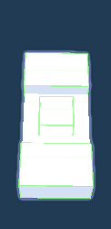

or WallBrush for Wall Block

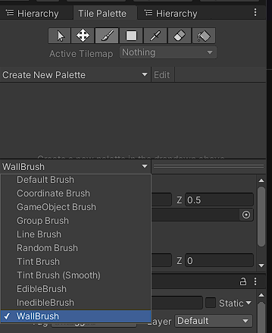 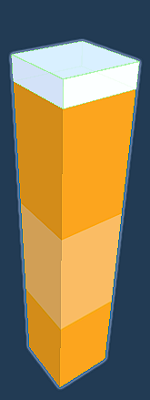

1. On Tile Palette Toolbar 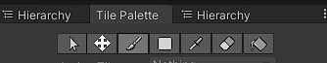, choose  (shortcut B) to draw object or (shortcut D) to erase object on the Tilemap named Map in the Scene window

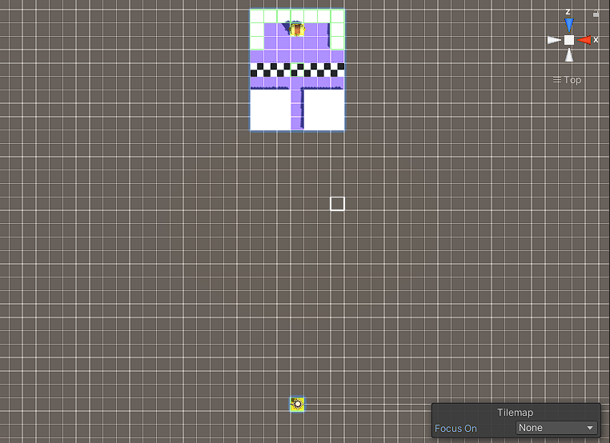

\*\*\*NOTE:

* Each brush will draw and erase only the object contained by this brush. Therefore, avoid overlapping between other brushes when you draw.
* You can change the Win object’s position. However, you shouldn’t change the player's position. It’s rooted
* The final map should look like this

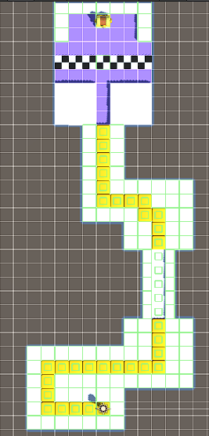 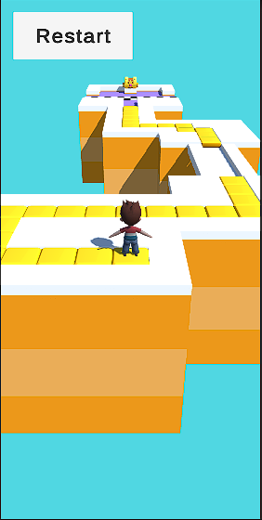

In Scene view In Game view

1. Final step, when you’ve done drawing. Change the level number in the Game Controller’s Inspector. It will be the name of the level (like Level 10,...).

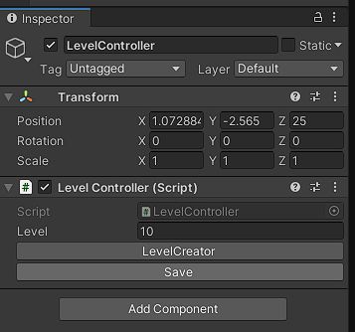

Then click Save, a new level prefab with level name (Level 10) will be created at Assets/Gameplay/Resources/Levels folder 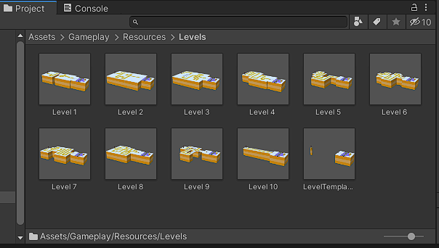

1. Bonus Function: Edit Level

You can choose the level you want to edit by filling the level order in “level” field and then click Edit Level Button.

The corresponding Level Prefab will be load to scene for you to edit (If there is no level with that order, unity editor will automatically log an error message.

However, you must use Eraser Brush to erase the old one’s component

\*\*\*NOTE:

* If there is an existing level with the same name. The old one will be overwritten.
* After clicking Save, the LevelTemplate(Clone) will be destroyed. Therefore, if you want to create another level, restart from step 3.
* If you want to stop creating the level, click Stop Button
* A screenshot of a computer

  Description automatically generated with medium confidence
* The “Reset Data Level” button help you replay from level 1.

That’s all. Hope you can use it easily !!!! Thank you